**Homework #1**

**CS 5665, Fall 2016**

For assignment #1 I have used following stuffs:

* For this assignment I have used Microsoft Excel 2013 for data manipulation and visualization
* I have taken the relevant data from the csv files by copying and pasting them into different sheets created for different tasks.
* For handling missing attributes, I have not made any changes to data.

**Task 1. Water Usage Analysis:** First, we want to gain an understanding of the Water Usage of all buildings, and how these may vary across different departments.

1. Using the three main measures of central tendency (mean, median and mode), analyze the Water Use for all buildings, as well as for individual departments (say, for the top-5 departments). You should plot box-plots for all buildings, as well as for the individual departments.

Ans:

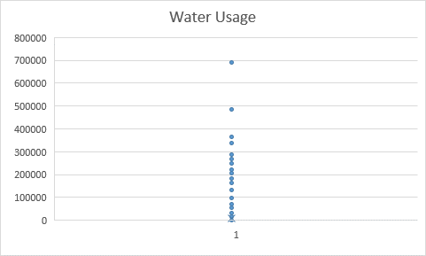s

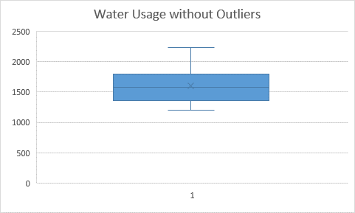

Top 5 departments:

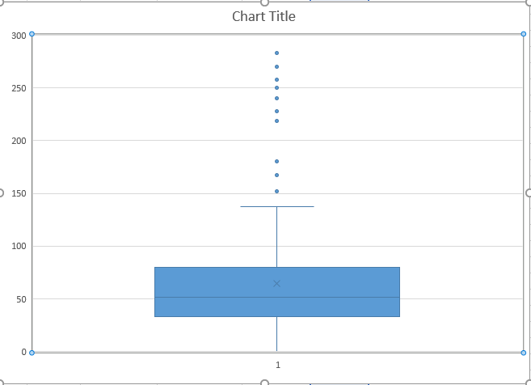

Cal Fire

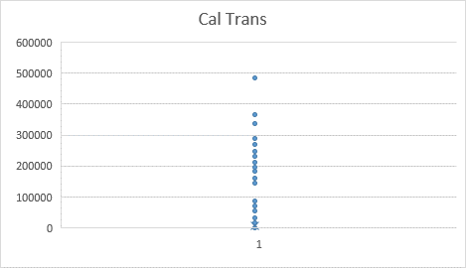

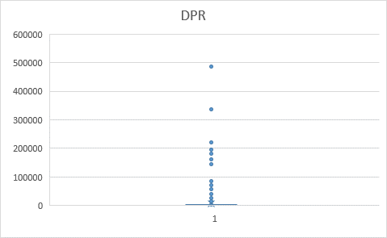

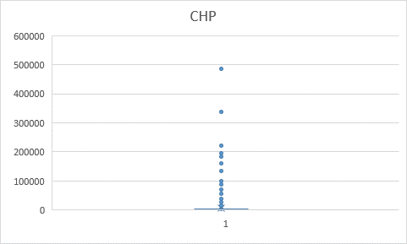

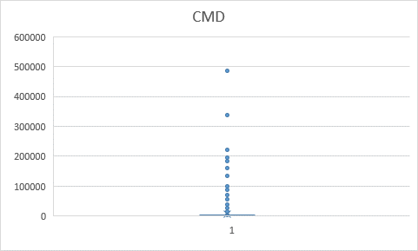

|  |  |  |  |  |  |  |  |
| --- | --- | --- | --- | --- | --- | --- | --- |
| **Normal Mean** | **Normal Median** | **Normal Mode** | **Quartile 1** | **Quartile 3** | **Interquartile Range** | **Lower Bound** | **Upper Bound** |
| 6563.689076 | 224.6 | 165 | 96.075 | 952.825 | 856.75 | 1189.05 | 2237.95 |

1. Now, remove outliers by dropping all water usage that are "too extreme". Be sure to quantify your definition of "too extreme" and explain how you arrived at that definition. Compare the mean, median, and mode without outliers. What do you observe?

Ans:

Too extreme/outlier: These are the values that are obtained by removing most extreme values. But for me I have calculated "Lower Bound & Upper Bound" value using the Interquartile value and then removed the values which are lesser than lower bound and greater than upper bound values.

|  |  |  |
| --- | --- | --- |
| **Outlier Mean** | **Outlier Median** | **Outlier Mode** |
| 1618.2224 | 1580.8 | 1256 |

The central tendency values have changed very much. The mean value has decreased while the median and the mode value increased a lot. But theoretically, the mean value gets affected the most while median and mode change very less.

**Task 2. Resource Usage Correlation:** Does a relationship hold between the Water Use of a Building and its Electricity Use?

|  |
| --- |
| **Pearson's Correlation** |
| 0.700323281 |

1. Plot this relationship using a scatter plot, and report the correlation (using Person's correlation coefficient).

Ans:

1. Now find the top 5 departments based upon the number of buildings and perform the same analysis for these 5 departments. Based upon these plots and Pearson correlation values what can you conclude?

Ans:

The Pearson coefficient of top 5 department:

Cal Fire - 0.299

Cal Trans - 0.732

CMD – 0.286

DPR – 0.108

CHP – 0.897

**Task 3. Building Similarities:** Using two distance metrics (Euclidean and Manhattan) and one similarity function (Cosine), find the three buildings similar to following buildings.

|  |
| --- |
| **Property Name** |
| MENDOTA MAINTENANCE STATION |
| METROPOLITAN STATE HOSPITAL |
| LONG BEACH FIELD OFFICE |

1. Resource Usage only: Electricity Use, Natural Gas Use, Propane Use, Water Use, Site Energy Use
2. Property variables only : Department Name,City, Primary Property Type, Property Area
3. All above 2 types of dimensions together

Ans: The similar buildings using the dimensions provided in the question are as follows:

|  |  |  |  |
| --- | --- | --- | --- |
| **MENDOTA MAINTENANCE STATION** | | | |
|  | Euclidean Distance | Manhattan distance | Cosine similarity |
| Resource Usage Only | - Oroville area  3931.757728  - Torrance (State Owned)  10262.35744  - Fremont maintenance station  13123.35676 | - Oroville area  5710.499996  - Torrance (State Owned)  12913.6378  - Orange (State Owned)  15479.04278 | - Oroville area  0.0000717690  - Torrance (State Owned)  0.000434664  - Ferrellgas  0.000753166 |
| Property Variables Only | -Alameda Maintenance Station 29.0688837074973  -Mount Shasta Area 31.559467676119  -Vincent S/S 73.6613874428116 | -Alameda Maintenance Station 31  -Mount Shasta Area 48  -Vincent S/S 86 | -Vincent thomas bridge maintenance station 0.0000030580135181868 (Paint)  -Porterville area  0.00000349995732  -Willows area  0.00000412088910 |
| All dimensions | - Oroville area  4325.554511  - Fremont maintenance station  13124.97823  - Manzanita maintenance station  13961.42949 | - Oroville area  7583.499996  - Fremont maintenance station  15965.19999  - Manzanita maintenance station  20422.64581 | - Oroville area  0.0000939397  - Ferrellgas  0.000804833    - Manzanita maintenance station  0.000931998 |

|  |  |  |  |
| --- | --- | --- | --- |
| **METROPOLITAN STATE HOSPITAL** | | | |
|  | Euclidean Distance | Manhattan distance | Cosine similarity |
| Resource Usage Only | - Daa 22, San diego county fairgrounds  578653.0492  - Patton state hospital  3593816.735  - Meadowview  3969122.589 | - Daa 22, San diego county fairgrounds  667634.0056  - Patton state hospital  3600558.4  - Meadowview  3984573 | - Daa 22, San diego county fairgrounds  0.000494473  - Southern division headquarters  0.00901646  - Patton state hospital  0.013671387 |
| Property Variables Only | - PBSP-Pelican bay state prison  2556.72212  - Lac- California state  10538.46398  prison, los angeles county  - Sonoma DC  20667.69532 | - PBSP-Pelican bay state prison 2820  - Lac- California state 10665prison, los angeles county  - Sonoma DC 20854 | - Patton state hospital  0.0000000002  - Sol-California state prison, Solano  0.0000000003  - SQ-san quentin state prison 0.0000000009 |
| All dimensions | - Daa 22, San diego county fairgrounds  695544.4996  - Patton state hospital  3593896.719  - Meadowview  4116497.937 | - Daa 22, San diego county fairgrounds  1053804.096  - Patton state hospital  3624571.563  - DMV HW campus – east building  4805542.313 | - Daa 22, San diego county fairgrounds  0.000831958  - Southern division headquarters  0.013683101  - Patton state hospital  0.018510132 |

|  |  |  |  |
| --- | --- | --- | --- |
| **LONG BEACH FIELD OFFICE** | | | |
|  | Euclidean Distance | Manhattan distance | Cosine similarity |
| Resource Usage Only | - Csr-Slu San Luis Obispo FS - 2014 E Complete  3299.738234  - American river fish hatchery  4380.921702  - 925 Bolsa chica sb  19283.06237 | - Csr-Slu San Luis Obispo FS - 2014 E Complete  5188.3  - American river fish hatchery 6810.4  - Cajon maintenance station 25727.9 | - Csr-Slu San Luis Obispo FS - 2014 E Complete  0.0000034430  - American river fish hatchery  0.0000127924  - Cajon maintenance station  0.0000392245 |
| Property Variables Only | - 715 Castle rock SP 52.1056618804521  - Montebello office building  104.6565813  - Oroville (State Owned)  139.8320421 | - 715 Castle rock SP - 57  - Montebello office building - 141  - Crescent city maintenance system  -196 | - 715 Castle rock SP  0.00000001489  - 730 Turlock lake SRA  0.00000008743  - Oakland coliseum building  0.00000019482 |
| All dimensions | - American river fish hatchery  5841.24661  - Cajon maintenance station  19657.53805  - 925 Bolsa chica sb  29169.86024 | - American river fish hatchery  10835.4  - Cajon maintenance station 26997.9  - 925 Bolsa chica sb  49305.7 | - American river fish hatchery  0.00002771619  - Cajon maintenance station  0.00004117034  - Bishop Area  0.00015215278 |